PROJECT REPORT

1.INTRODUCTION

## 1.1 OVERVIEW

It was on of the most subscriber channels . collection of Bollywood music,vedios and Indian pop culture content.cocomelon-nursery rhymes channel primarily focus on children songs and animation,making it a popular choice for parents and kids .5-mins craft known for quick and creative DIY projects,life hacks,and other useful tips and tricks. Set india featuring a wide range of Indian television shows ,dramas and reality programmes.WWE is the official channel of world wrestling entertainment,showcasing wrestling matches,highlights.an behind the scenes content .due perfect is a sports and entertainment groups that creates trick shorts and fun challenges.

## 1.2 PURPOSE

Educational channels provide valuable information and insights on a wide array of topics. Channelws like Philip DeFranco CNN provide news updates,analysis and commentary on current events.Travel vloggers like casey neistat and the food ranger document their adventures,inspiring viewers to explore the world.fitness enthusiasts like athlean-X and blogilates offer workout routines,nutrition advice,and motivation for healthy living

# 2.PROBLEM DEFINITION & DESIGN THINKING

**2.1 EMPATHY MAP**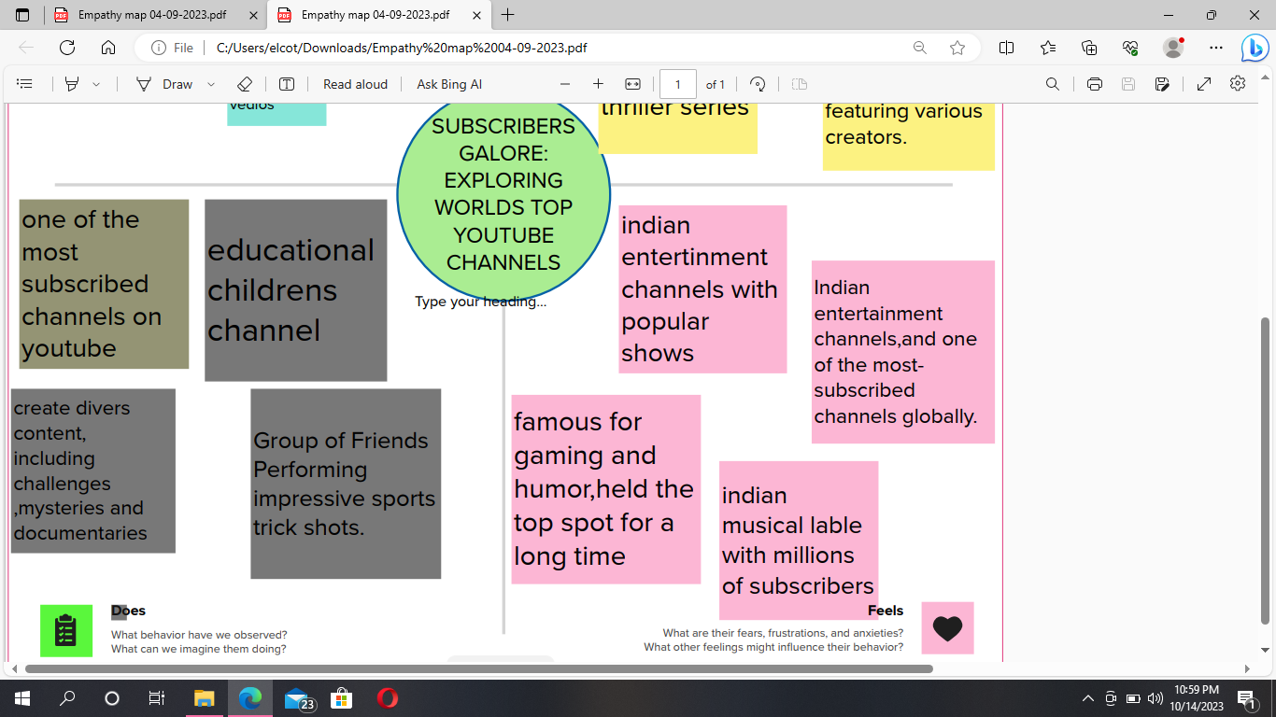

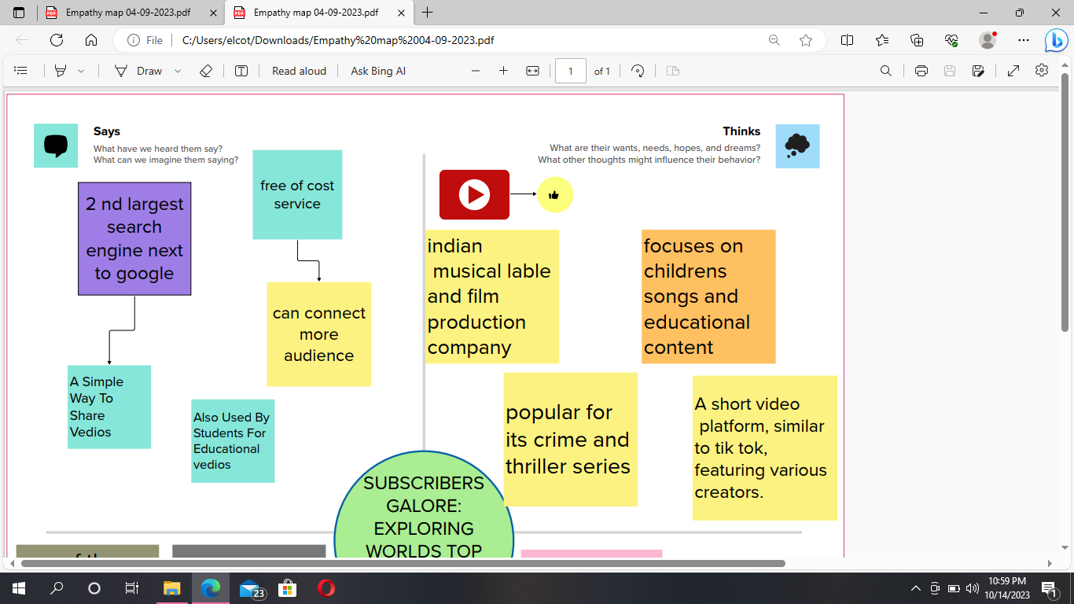

**2.2 IDEATION & BRAINSTORM MAP**

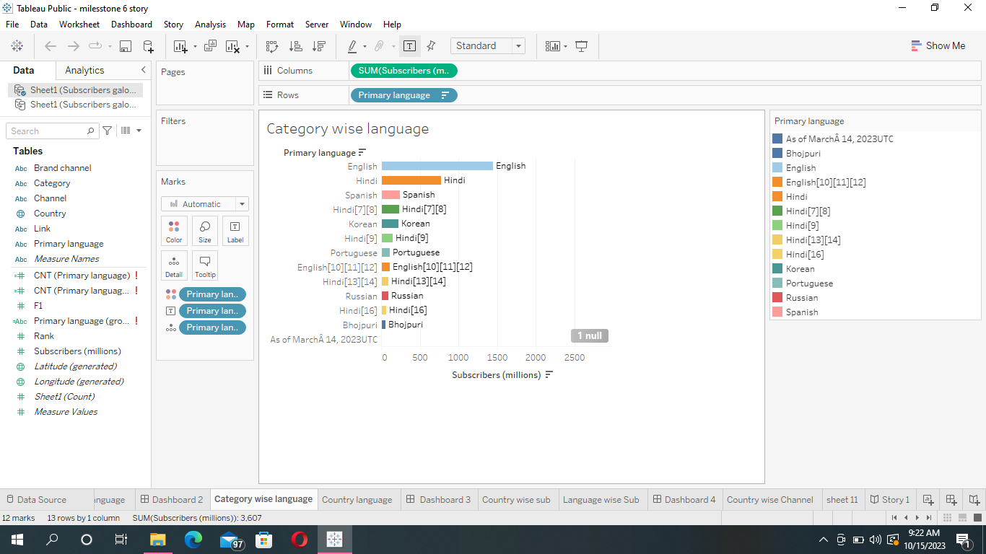

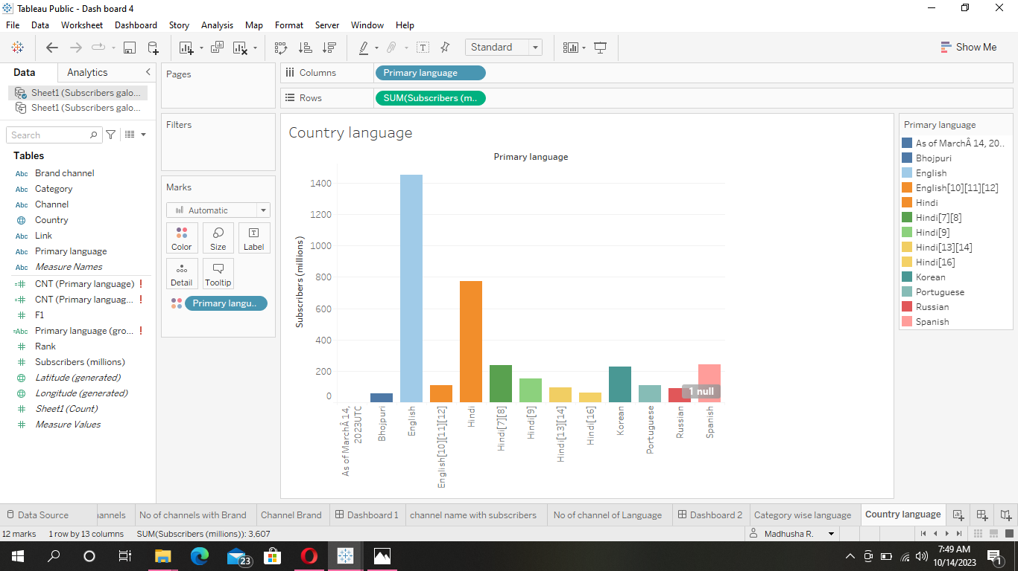

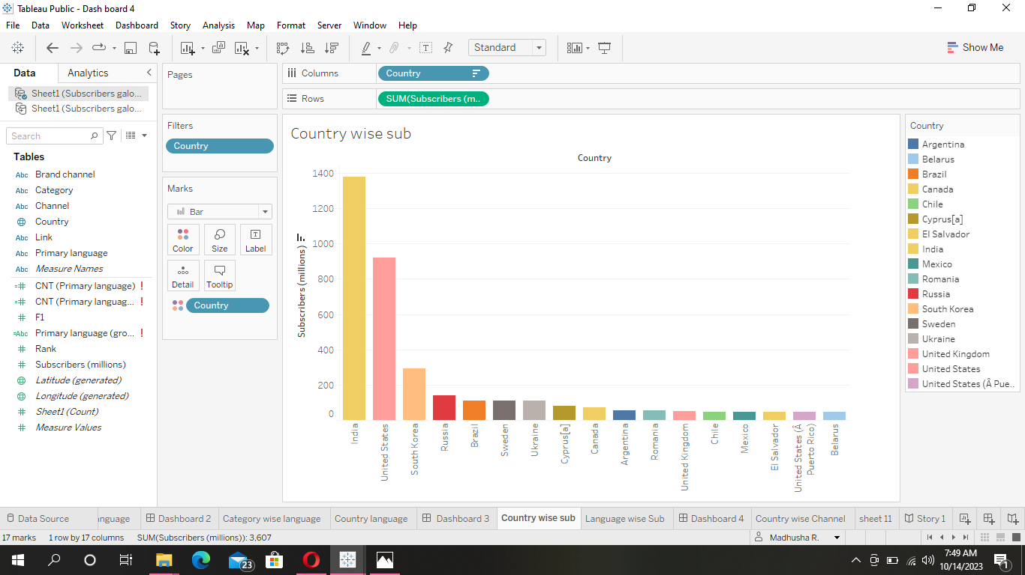

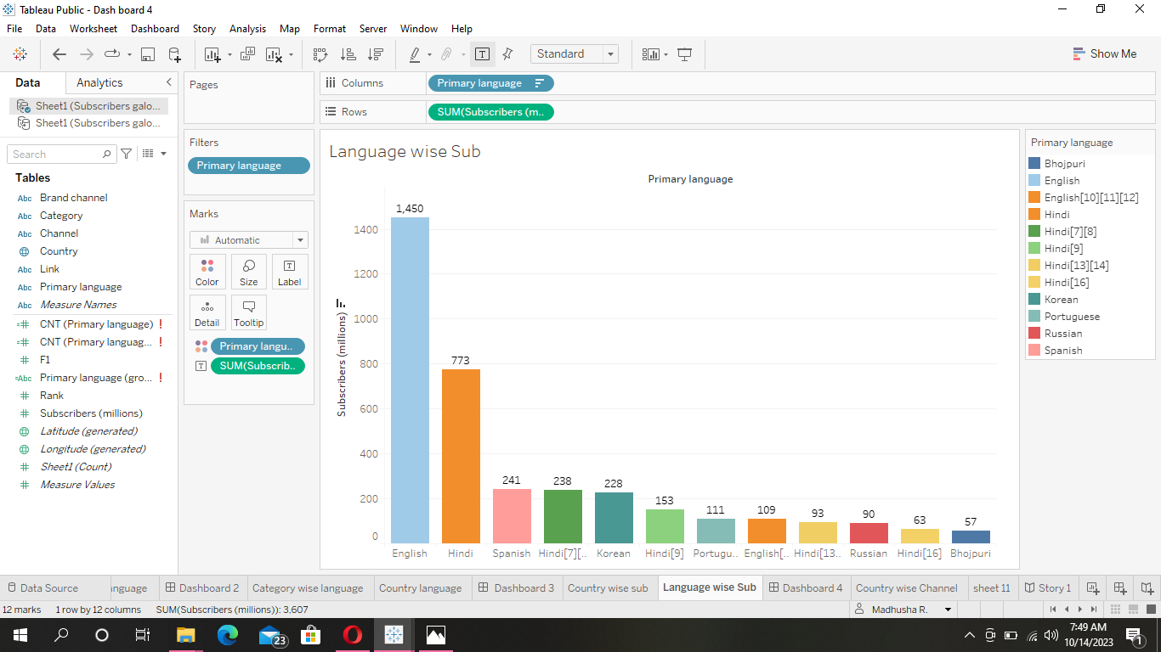

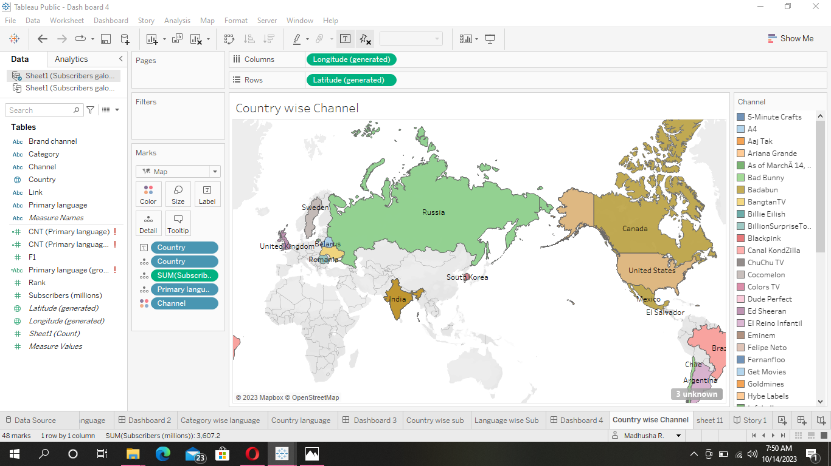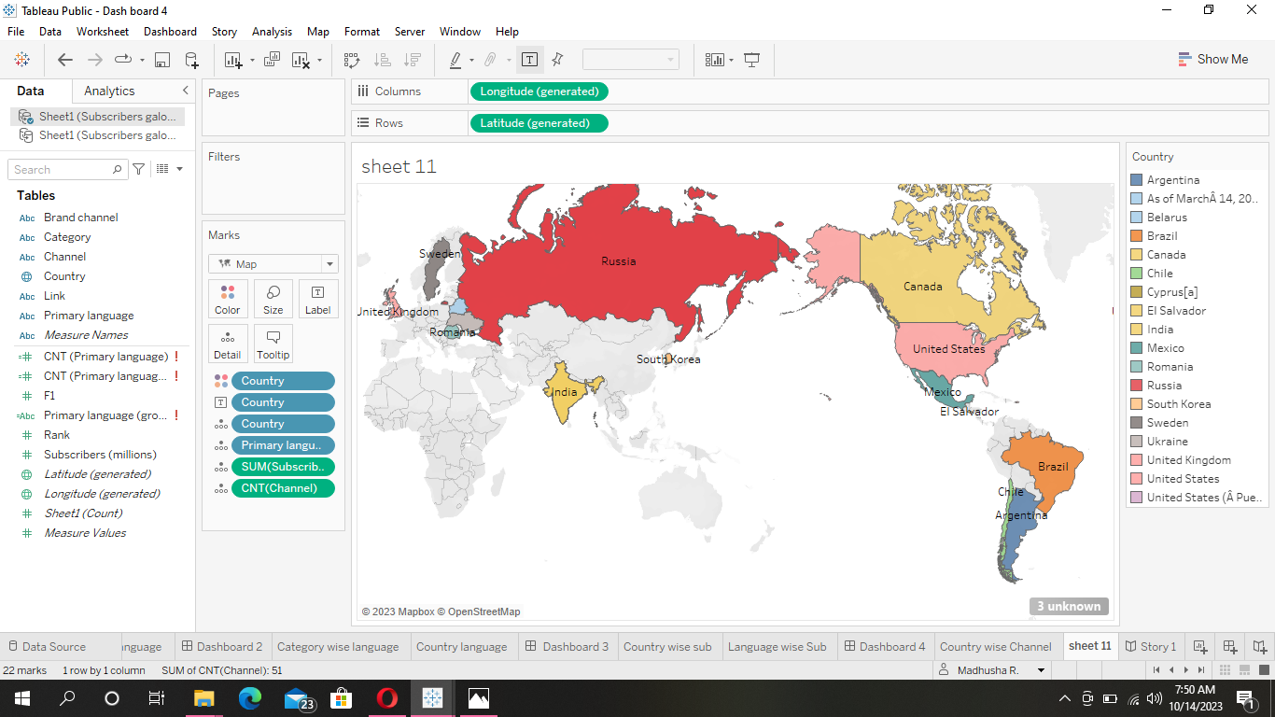

4.ADVANTAGES AND DISADVANTAGES:-

ADVANTAGES:-

BRAND COLLABRATION:-

Top channels often attract collabrations with well known brands providing additional income and exposure.

INFLUENCE AND IMPACT:-

Youtube influencers can use their platforms to promote causes they care about,fostering positive change.

CREATIVE FREEDOM:-

Established youtubers have the creative freedom to explore diverse content and engage with their audience on their terms.

PESONAL BRANDING:-

Youtubers can build and leverage their personl brand for ventures beyond youtubes,such as books,merchandise,or speaking engagement.

DISADVANTAGES:-

COSTANT PRESSURE:-

Maintain a high level of content quality and consistency can be mentally and physically draining .creaters often face the pressure to keep their subscribers engaged.

HIGH EXPECTATIONS:-

Subscribers of popular channels expect a certain level of quality and may become critical if the content doesn’t meet their expectations .

COPY RIGHTS ISSUES:-

Larger channels may face more copy right claims and legal challenges due to the use of copy righter material or potential conflicts with other creators.

5.APPLICATIONS :-

EDUCATION :-

VSAUCE:-

Vsauce engaging science and curiosity-driven content.

CRASHCOURSE:-

Provides educational videos on a wide range of topics.

KURZGESAGT-IN ANUTSHELL:-

Explains complex scientific topics in a easy to understand manner.

COOKING AND FOOD:-

TASTY:-

Offers easy to follow cooking and recipe vedios.

BINGING WITH BABISH :-

Recreates dishes from movies and TV shows.

TRAVEL AND LIFE STYLES :-

WOLTERS WORLD:-

Provides travel tips ,advice and destination reviews.

TLC :-

Features various life and reality shows

6.CONCLUSIONS:-

The worlds top youtube channel vary greatly in content,from entertainment and music to educational and gaming channels.They have amassed millions of subscribers,creating a massive impact on the platforms.while the specific channels in the top spots may change over time.youtube remains a hub for content creators to reach a global audience and build dedicated fan bases.

7.FUTURE SCOPE:-

COLLOBRATION AND CROSS PROMOTION:-

Top channel of an collaborate with other creaters , which can help boost their exposure and reach new audiences.

MONETIZATION:-

Top channel can continue to explore various monetization options,including adds ,sponsorships,merchandise,andmembership programs .

LIVE STREAMING:-

Live streaming has gained popularity,and ,many channels are using it to interact with their audience in real time.

8.APPENDIX:-

Since its launch in 2005 ,youtube has become the ultimate destination for entertainment,offering a diverse range of content,from hilarious moments to news updates and educational resources.Among the plethora of channels,aselect few have risen to the top,securing a place in the worlds top 10 most subscribed youtube channels articles,delve into the fascinating journey of these influential channel,as of SEPTEMBER 2023.